# MotoMatch

MotoMatch is a personalized motorcycle search platform, built with React, Node.js, Express, and MongoDB, that helps users find the perfect bike based on their preferences and riding needs.

**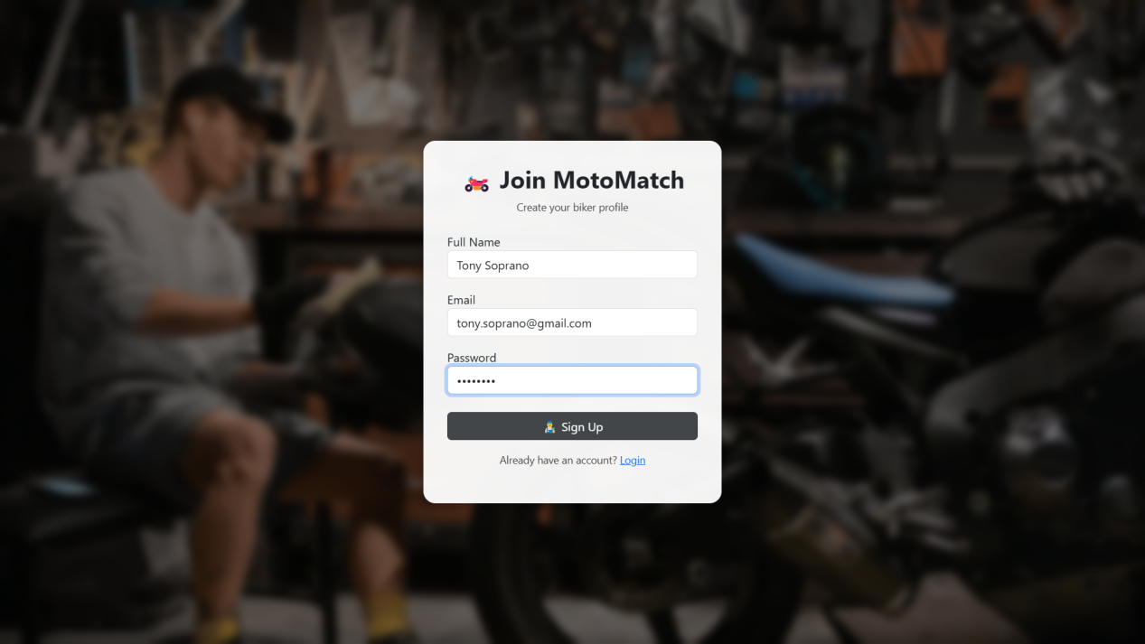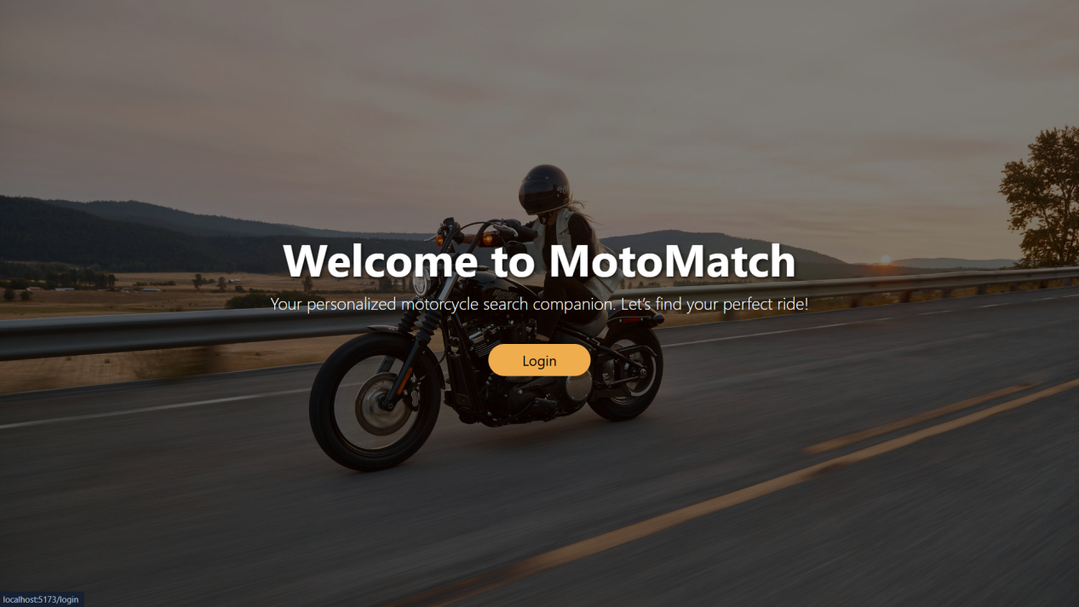  
  
Before Login Page   
  
  
Signup Page   
  
Sign-Up Successful Alert Box   
  
Signup details sucessfully stored in MongoDB  
  
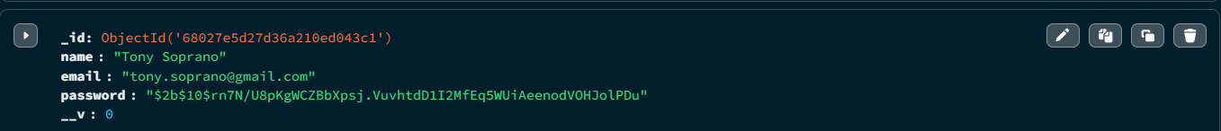  
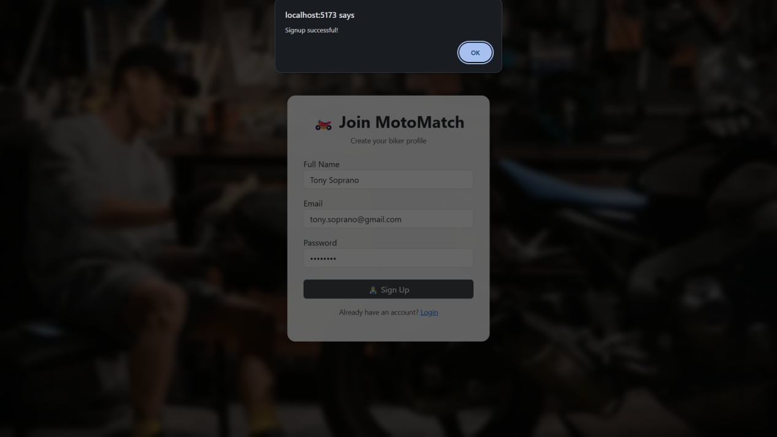**

**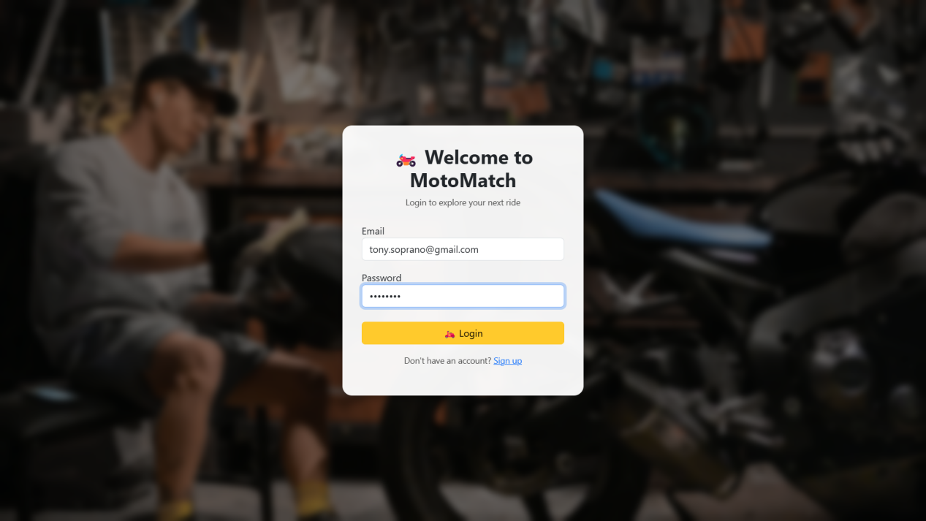  
Login Page**

**Main Home Page**

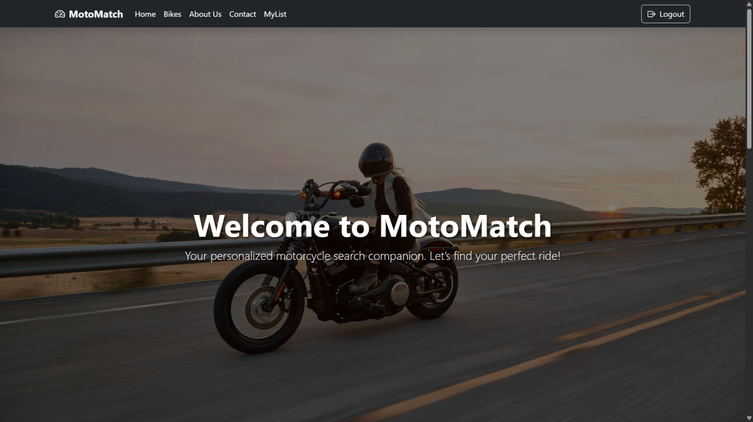

**Bikes Section**

**Searching Bike**

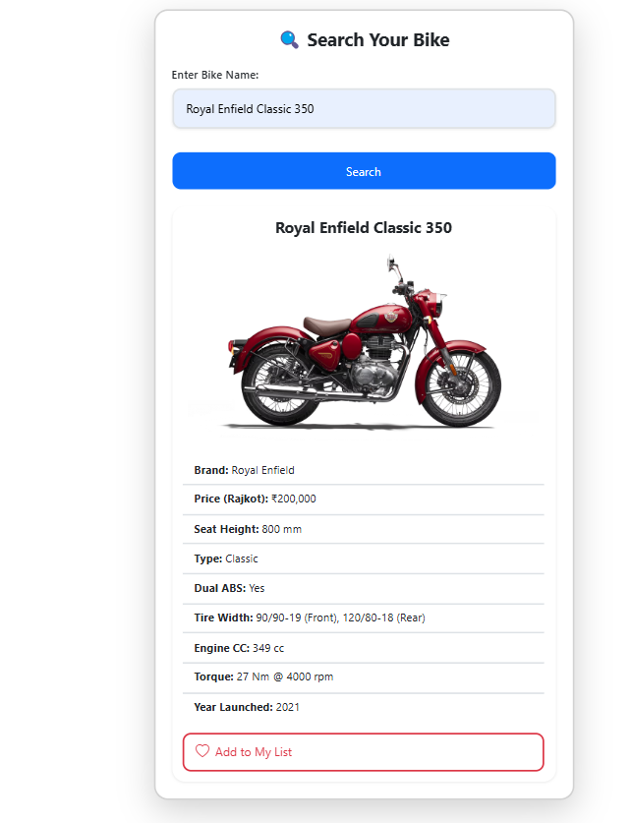

**My List Page (Where Added to List Bikes Appears)**

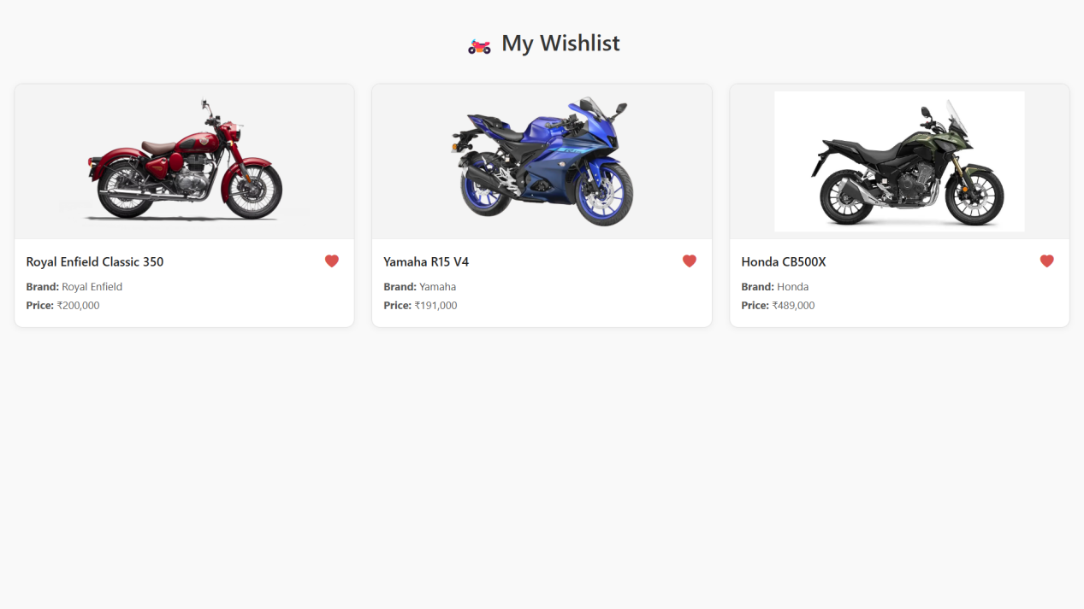

**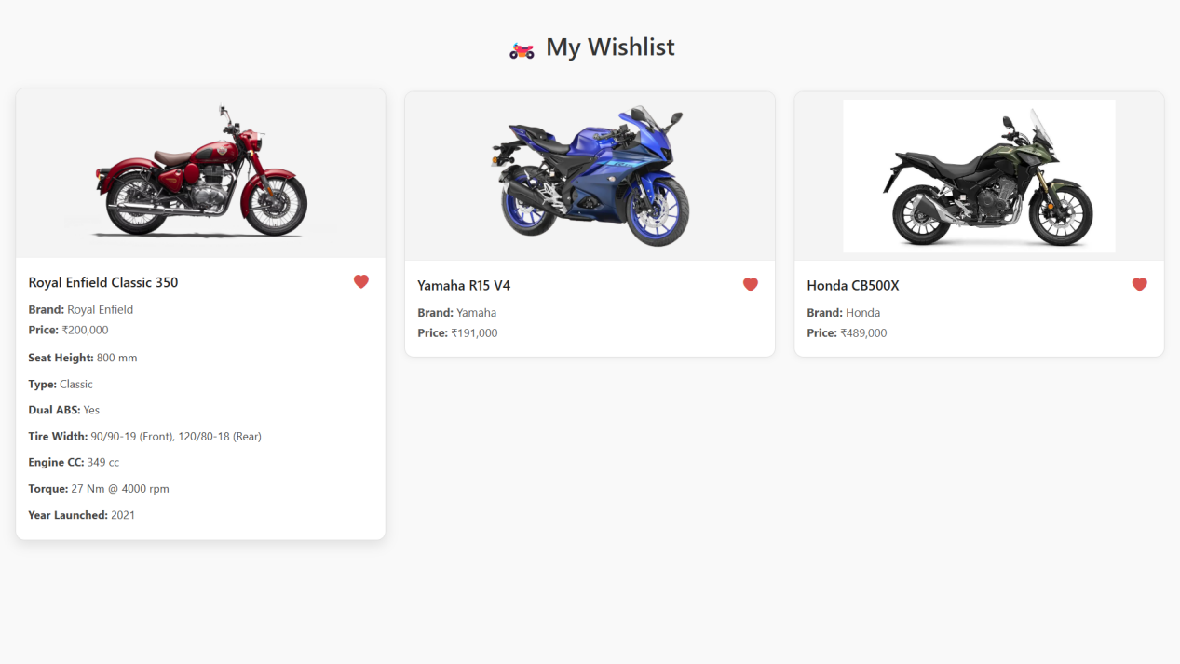  
  
Bike Details (Onclick)  
  
  
  
  
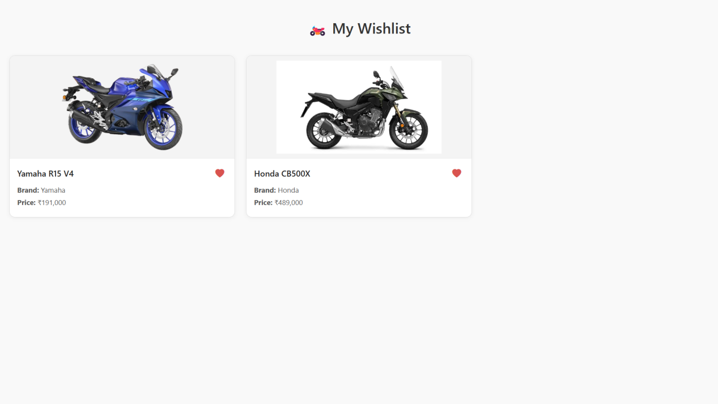Removing Bike from My List Page   
  
By clicking on heart icon  
  
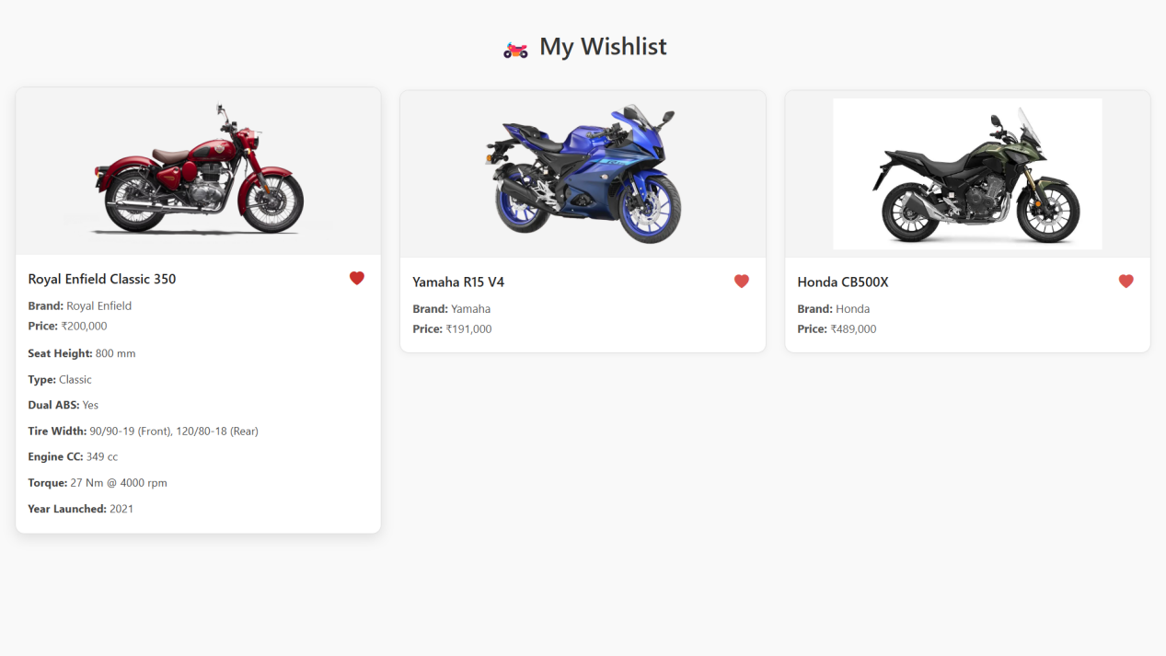  
  
Bike Removed  
  
  
  
  
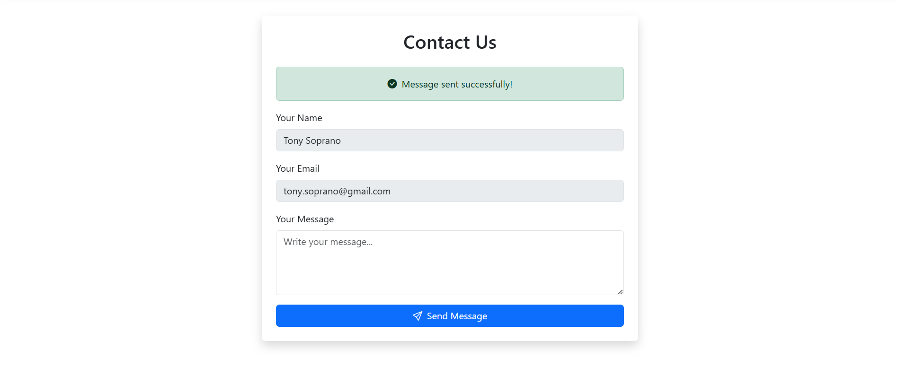  
About Us Section  
  
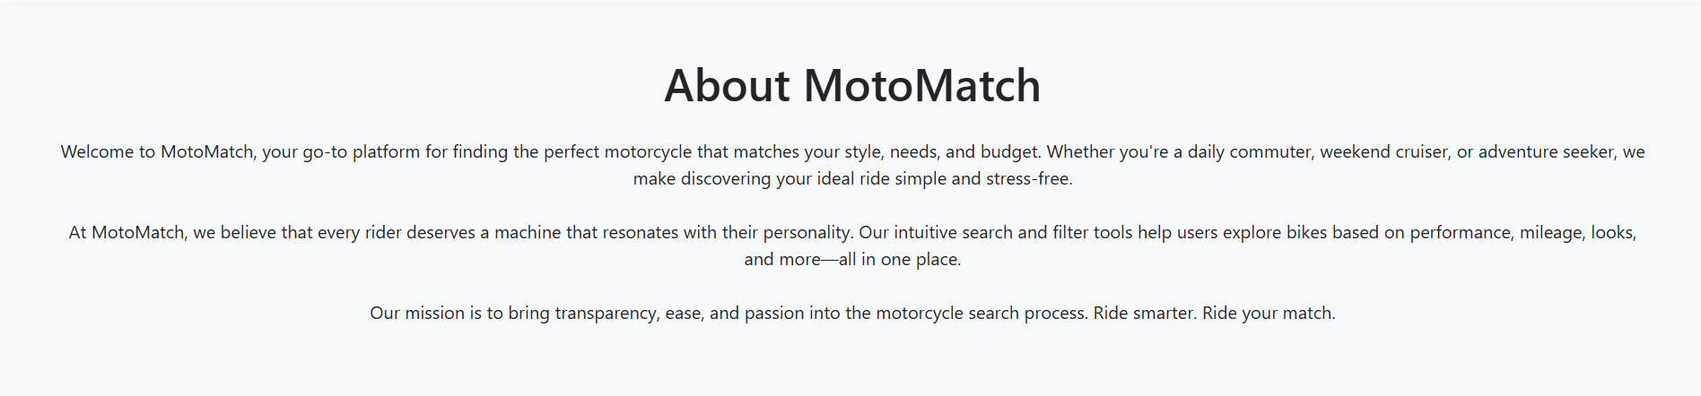  
  
  
Contact Us Section  
  
  
  
  
  
  
  
  
  
  
  
  
  
  
  
  
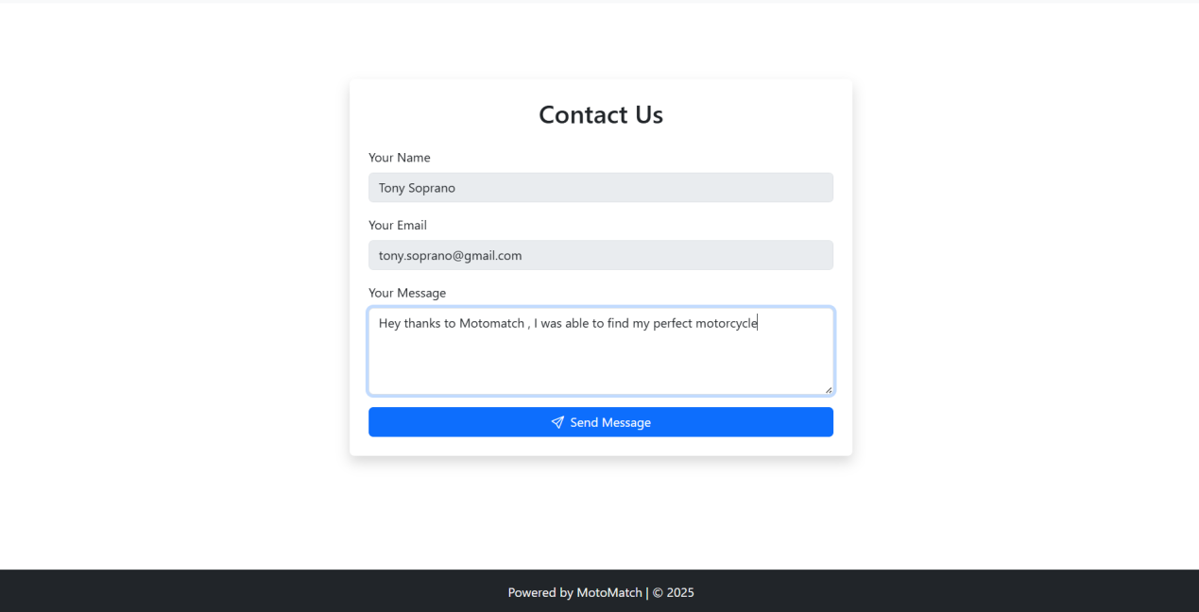Contact Us Message Sent Sucessfully   
  
  
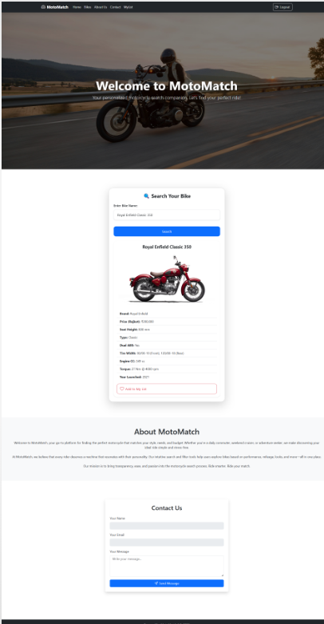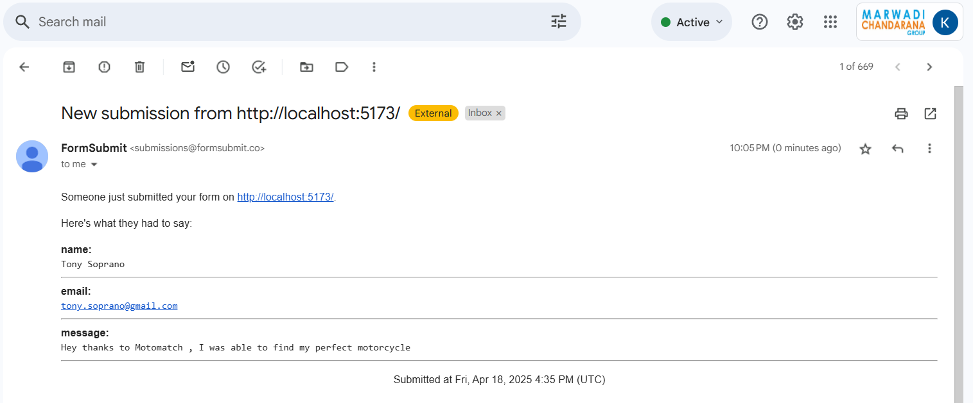Contact Us Mail Received in My Inbox   
  
Full Webpage Screenshot**